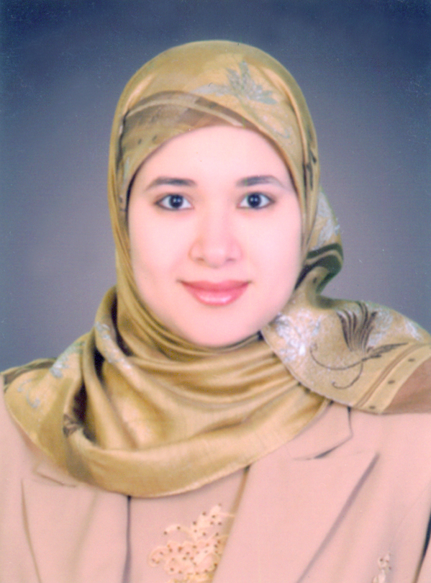
C.V

na

Ghada Abdelrahman Mohammad
Staff member of Internal medicine,Diabetes and Endocrinology
Faculty of medicine
Assiut University Hospital
Personal information :
Name : Ghada Abdelrahman Mohammed Mohammed
Date of Birth : 1/ 11/ 1980
Address : Egypt – Assiut – Assiut university hospital .
Mobile :+201004301177 & +201008816412
Home Tel : +2088289880
E-mail : ghadaa1980@yahoo.com
Merital status : Married. My husband is specialist
gastroentrology,hepatology and tropical medicine in
Police Hospital
Languages :

Arabic (mother Languages ) .
English ( fluten written and spoken )
French ( as asecond foregin Language during the hight school )
Education :

M.B.B.Ch in medicine and Surgey in 2003 , Faculty of Medicine ,Assiut University .

Master Degree (M.Sc ) in Internal Medicine in 2008 from Assiut University .
with thesis titled " value of myeloperoxidase (mpo) as an early marker of cardiac ischemia and its prognostic value in prediction of myocardial infarction".
- Doctor degree in Internal Medicine in 2013 Faculty of Medicine ,Assiut University .
- with thesis titled " Diagnostic value of B- Natriuretic Peptide, ankle–brachial index and carotid Doppler in detection of sub-clinical cardiovascular disease in type 2 diabetic patients"

Profissional record :
Name of Institution | Location | Position | Year  (From – To)
1-Department of medicine, faculty of medicine,Assiut university, Egypt | Assiut, Egypt | Lecturer of Internal Medicine ,Diabetes and Endocrinology | 2013
1- Department of medicine, faculty of medicine, Assiut university, Egypt | Assiut, Egypt | Assistant Lecturer of Internal Medicine , Diabetes and Endocrinology | 2008-2012
1- Department of medicine, faculty of medicine, Assiut university, Egypt | Internal Medicine and Endocrinology | Resident in Internal Medicine | 2005-2008
1- Department of medicine, faculty of medicine, Assiut university, Egypt | Internal Medicine and Endocrinology | Demonstrator | 2004-2005

Clinical Experience :

CLINICAL PRACTICE :
As a resident physician And during my work as assisstent lecturer and lecturer at the following units in Assuit University Hospitals
1-Emergency unit:
All primary and advanced skills concerning diagnosis and management of cardiac,endocrinal, gastrointestinal , hepatic emergencies and coma of different aetiology (Renal-hepatic –endocrinal-neurological) and advanced cardiopulmonary resuscitation . All emergency cases are first managed at this unit for stabilization before transferring them to appropriate places .
2--Endocrinology unit I had the experience in the diagnosis and management of Diabetes and other endocrinal cases (thyrotoxicosis, hypothyrodism, short stature, acromegaly, diabetes insipidus,obesity ,diabetic foot,addison disease,cases of amenorrhoea, hypogonadism).
3- Rheumatology unit I had the experience in the diagnosis and management of different Rheumatological disorders like (systemic lupus erythromatosus, Rheumatoid arthritis,mixed connective tissue disorders,scleroderma and others).
4- Hematology unit I had the experience in the diagnosis and management of different Hematological disordes like ( cases of anemia of different aetiology , cases of purpura of different aetiology ,cases of leukemia ,lymphoma,bleeding tendency and others).
5- Cardiology unit I had the experience in the diagnosis and management of patient with Rheumtic fever, Rheumtic heart disease,infective endocarditis,Ischemic heart disease ,congestive heart failure,cases with arrythmias.
6-Nephrology unit I had the experience in the diagnosis and management of patient with chronic renal failure ,nephrotic syndrome ,uremic enchephalopathy,acute renal failure and other.
7- Gastroentrology and Hepatology unit I had the experience in the diagnosis and management of the different hepatology & gastroenterology cases such as acute and chronic hepatitis, liver cirrhosis and its complications, hepatic encephalopathy, hepato-renal syndrome, hepatic malignancy, infections of the liver such as amoebic and pyogenic abscess, upper and lower GI bleeding, acute and chronic diarrhea, acute and chronic pancreatitis, gastrointestinal malignancies, peptic ulcer diseases, reflux diseases, acute abdomen, functional gastrointestinal disorders.
I am specialized as an endocrinologist and I have the experience in the diagnosis and management of the following:

1- All primary and advanced skills concerning diagnosis and management of all types of Diabetes Mellitus and its complication according to recent guidelines.

2- Diagnosis and managing cases of Thyroid disorders such as (thyrotoxicosis , hypothyroidism, goitre).

3- Diagnosis and managing cases of Adrenal dysfunction such as (Addison, cushing syndrome, conns syndrome)
4- Diagnosis and management cases of Pitutry dysfunction such as (acromegally, short stature ,delayed puperty, diabetes insipidus, galactorrhoea and hyperprolactinemia).
5- Diagnosis and managing cases of primary and secondary amenorrhoea,
polyglandular autoimmune endocrinopathy,and chrosomal abnormalities as turner syndrome.
6- Diagnosis and management cases of obesity.
7- Diagnosis and Management of endocrinal emergencies.

INVESTIGATORY SKILLS :
1- Basic skills for conducting and interpreting hormonal analysis .
2- Basic skills for conducting brachial ankle index to determine peripheral arterial disease in diabetc patient ( Performing around 300 cases in the Assiut University Hospitals)
3- Basic skills for dealing with Diabetic foot.
Professional memberships:
1- Membership of Upper Egypt Diabetes Association "UEDA"
2- Attendance and participation in several meetings held by the Egyptian Diabetes Association.

The Annual Scientific Meeting

1- 4 th International conference on Diabetes and Endocrinology of Upper Egyptian Group 2009.
2- The Egyptian Association of Endocrinology, Diabetes and Atherosclerosis "Physician Education Program" 2010.
3- 7 th International conference for Diabetes in upper Egypt (7 th -10 th Feb.2012)
4- Annual conference of integrated Medicine &Sleep Disorders Society (November 2013).
5- Fundamentals of Endocrine disorders and Diabetes ( 8 April 2014).
6- 30th annual conference of Faculty of Medicine - Assiut university ( 26 April 2014).
7- Medical Emergencies (19th-20th March, 2015.Assiut)
8- ADF(Arab Diabetes forum )conference of Diabetes (september 2016).
9- DIA Egypt conference of diabetes (october 2016).
10- Pan Arab conference of Diabetes (2017).

Attend and participate as speaker in following conferences.
1- 21th international congress of the Egyptian society of tropical medicine, infectious and parasitic diseases (ESTIP ,20-22 July 2016).
2- 12th UEDA coference of Diabetes (1- 4 February 2017).
3- Pan Arab conference of Diabetes (21-24 March 2017).
Attend & participate in the activities of following international conferences (Poster presentation)
1- 12th Annual Gulf Heart Association & 4th Kuwait cardiac society conference (March 4 -7, 2015 in Kuwait).

2- Fourth Clinical Congress of the Gulf Chapter of the American Association of Clinical Endocrinologists; 3-5 November 2016; Dubai, UAE
My Teaching duties:
In Department of Internal Medicine, Faculty of Medicine, Assiut University, Egypt.
1- For undergraduate medical student, faculty of medicine and faculty of pharmacy, faculty of Nursing, Assiut University, Egypt.
* A lecturer of all branches of basic and clinical medicine.
* A lecturer of basic and clinical of endocrinology, metabolism and diabetes.
2- For post graduate medical students, faculty of medicine, and faculty of Nursing, Assiut University, Egypt.
* A lecturer of advanced internal medicine & endocrinology for both post graduate medical and nursing students registered for either master and/or medical degree.
* A lecturer for post graduate medical students registered for Diploma degree.

